

Ethical Hacking

PRACTICAL LIST



December 24, 2024

Practical 1

We use whois.com to get information

Stap 1 : go your search Engen and find whois.com

Step 2 : click on official website

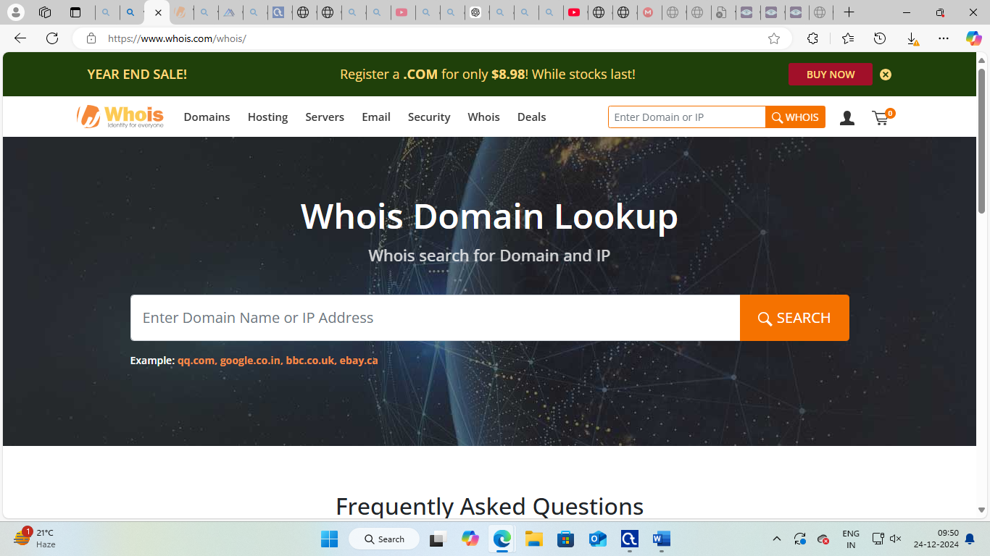

Step 3 : In search box type you website name and IP address

Step 4 : click inter and see your website detail

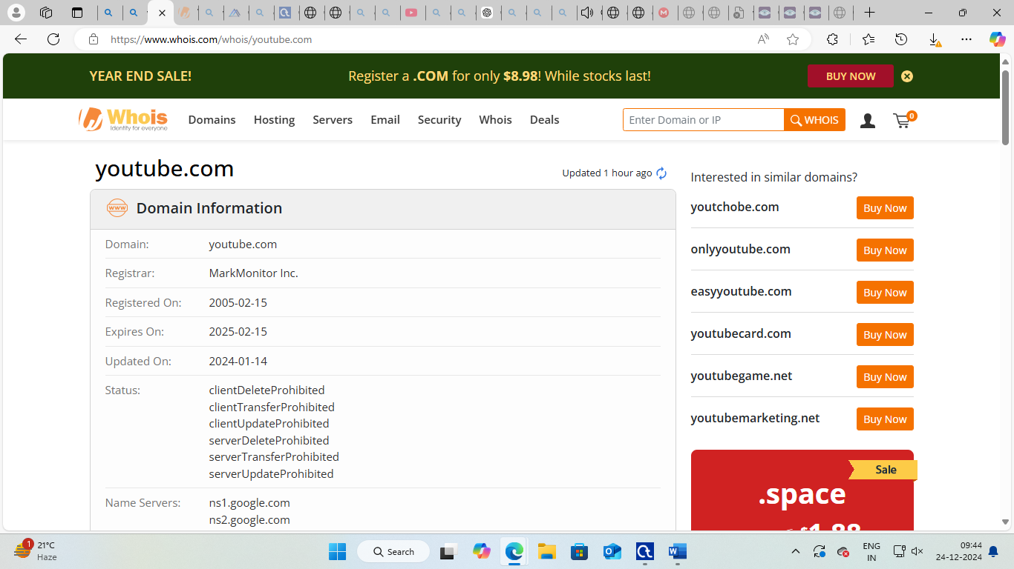

PRATICAL 2

Encryption and decryption

Step 1: download crypto tool and open

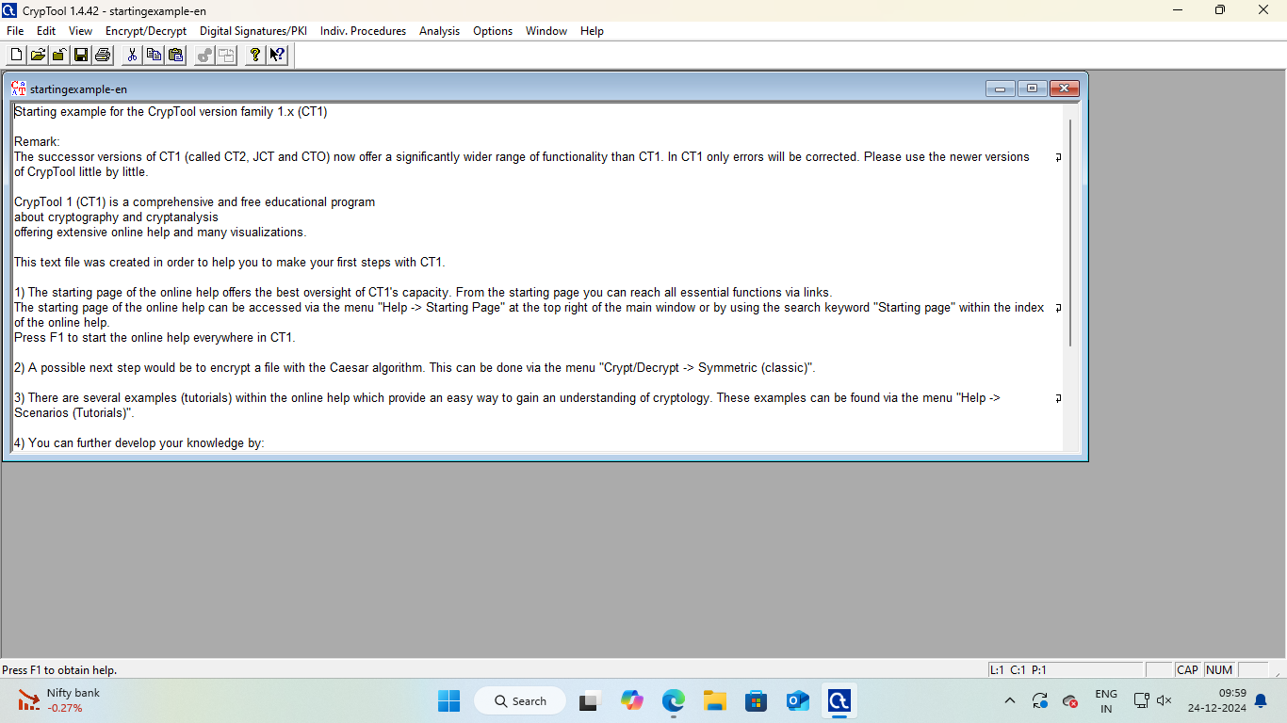

Step 2 : Go Encryption and decryption 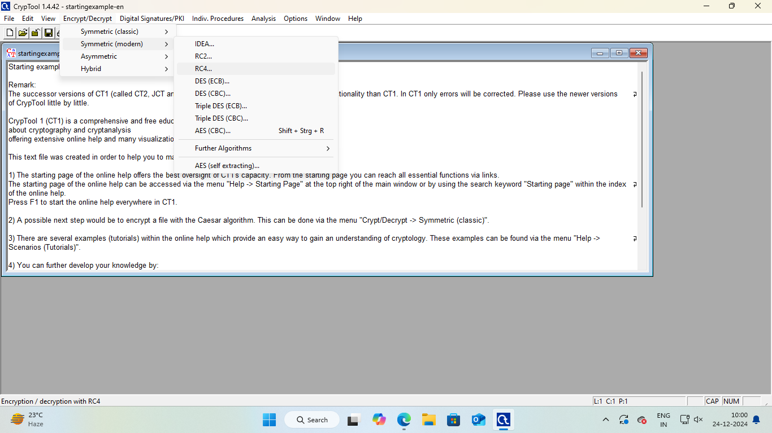

Step 3 : click RC4 for Encryption 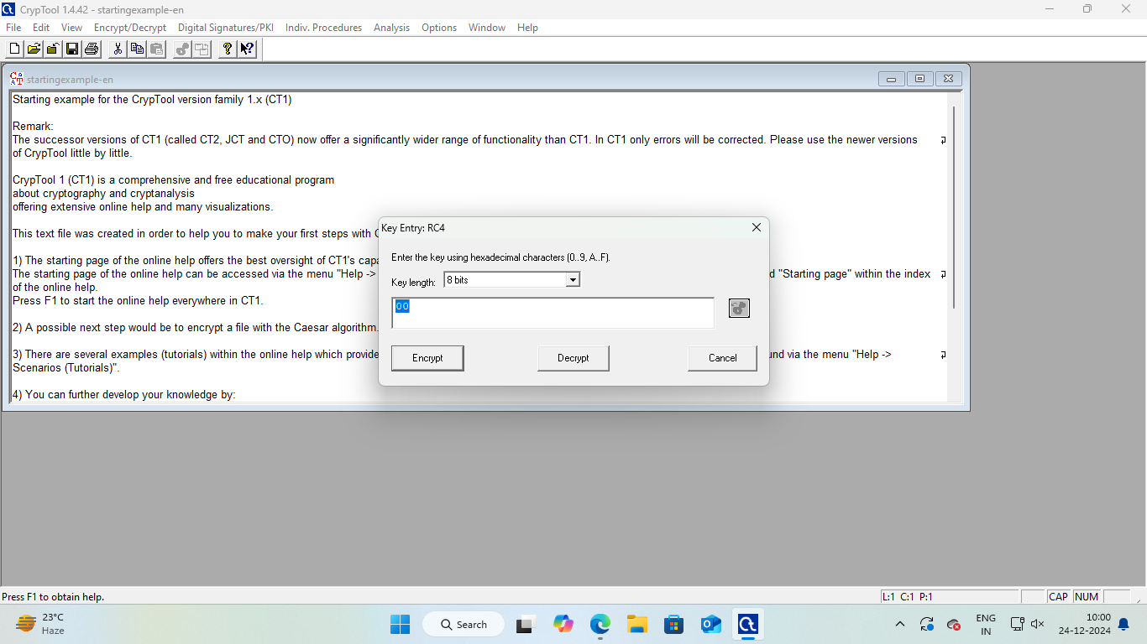

Step 4 : click to Encrypt

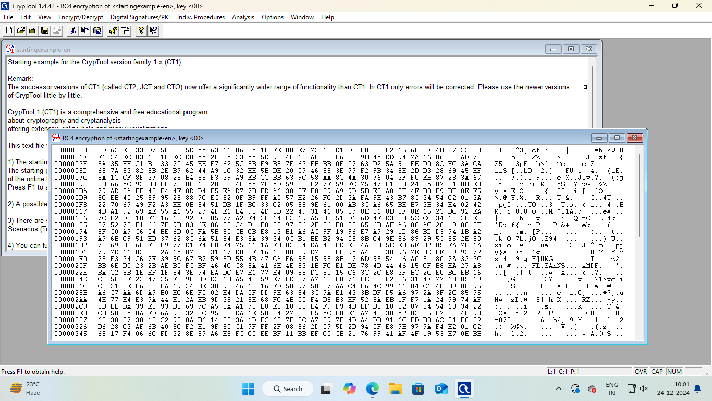

Note : when you perform all step then you get encrypt data(rc4)

**[DECRYPTION]**

Step 1 : copy your encryption data 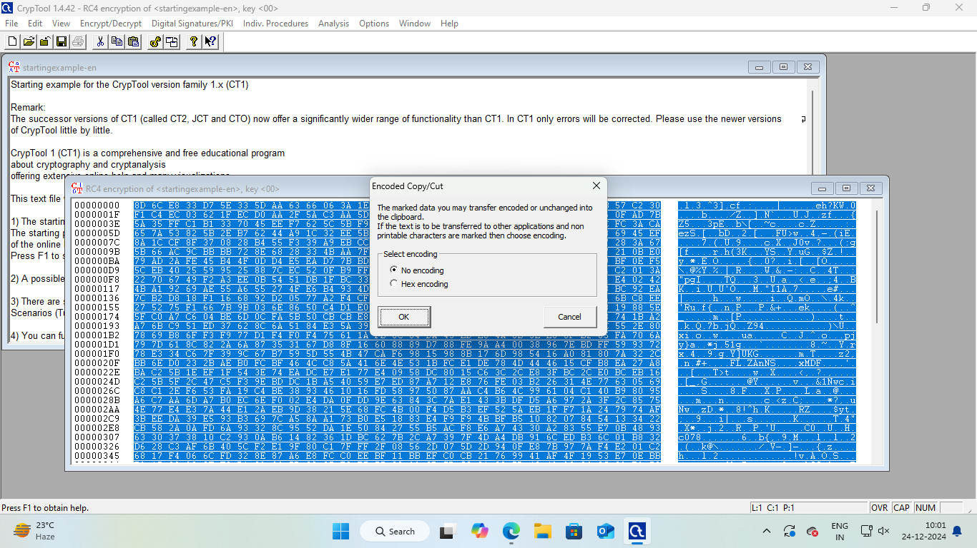

Step 2 :when you perform copy click [no encoding]



Step 3 : past our copy data in our new window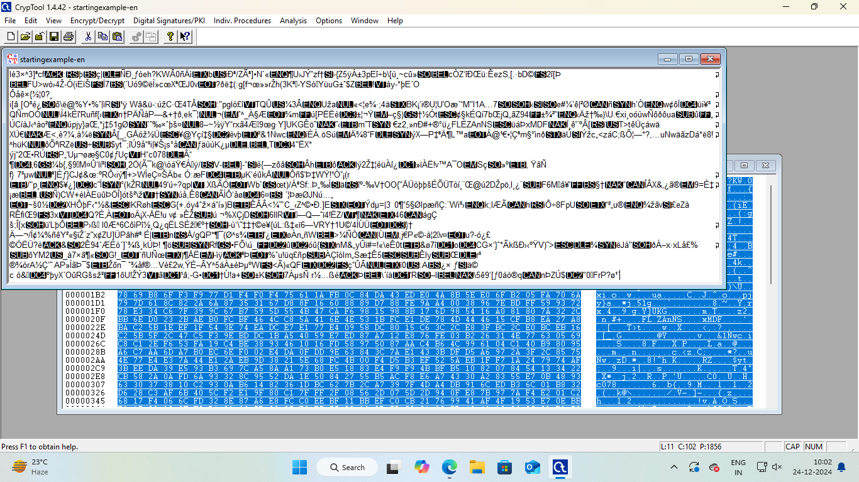

Step 3 : Go encrypt part and click in RC4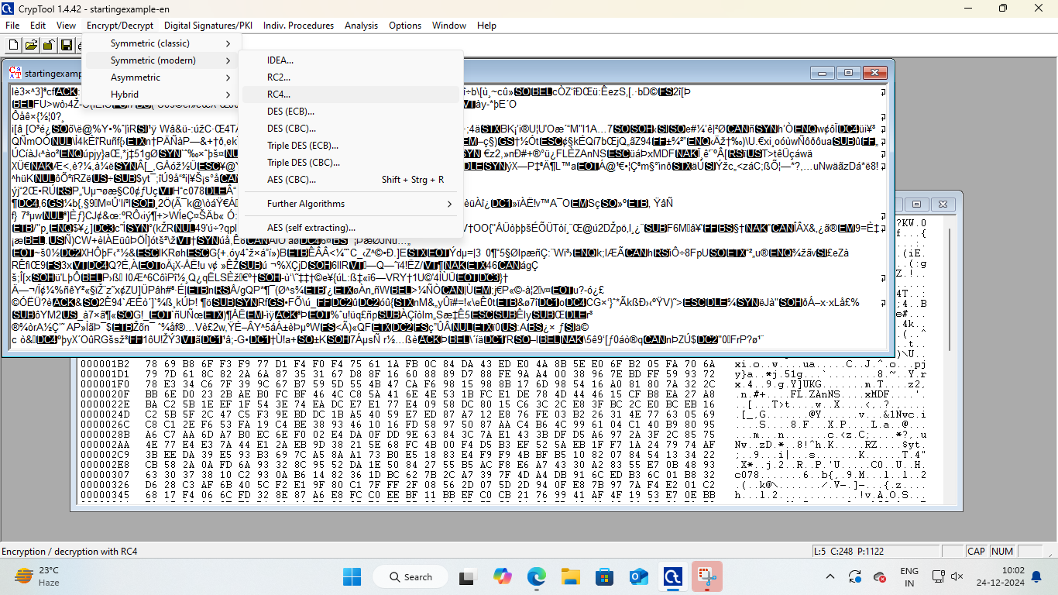

Step 5 : get your decryption data

